SRM INSTITUTE OF SCIENCE AND TECHNOLOGY
RAMAPURAM
Department: Computer Science and Business System
II Year B. Tech – Java Programming (21CSE269T)
ASSIGNMENT – I

Project 4
Inventory Management System

Report Submitted by:
S DARSHINI JEYA SHAKTHI
RA2411042020010

OBJECTIVE:
Designing and creating a system that can effectively manage inventory details is the main goal of this project. By employing file handling strategies, the system seeks to minimize human error and offer permanent storage.
Among the main goals are:
• To digitally store product data
• To automatically determine the total stock value
• To recover stored information upon program restart
• To use fundamental Java ideas in a practical setting
PROBLEM DESCRIPTION:
Product records are frequently kept by hand in small businesses or retail establishments. Errors, data loss, and trouble tracking stock value can result from this. It takes a lot of time to search for and update product details when records are kept manually.
The issue this project attempts to solve is the requirement for a straightforward and effective system to:
- Product details for the store
- Get saved data back
- Do a fast product search
- Determine the total value of the inventory.
- Preserve long-term storage
In order to address this issue, a console application built on Java is created that enables users to digitally manage inventory in an organized manner.
CLASS DESIGN:
The project consists of two main classes:
1. Product Class
The Product class represents a single product in the inventory. It contains the following attributes:
- id – Unique product ID
- name – Product name
- quantity – Number of units available
- price – Price per unit
The class includes:
- A constructor to initialize product details
- Getter method for product ID
- Method to calculate stock value
- Method to convert product data into file format
- Method to display product details
Encapsulation is implemented by declaring variables as private and accessing them through public methods.
2. InventoryManagementSystem Class
This is the main class that controls the entire program. It contains:
- An ArrayList<Product> to store products dynamically
- Methods to add, display, search, calculate total value
- Methods for saving and loading data from file
- The main() method where execution begins
This class manages user interaction and program flow.

CODE EXPLANATION:
The program starts execution from the main() method. When the program begins, it calls the loadFromFile() method to retrieve previously saved data from the file products.txt.
The system then displays a menu with options such as:
- Add Product
- Display Products
- Search Product
- Calculate Total Stock Value
- Save Products to File
- Exit
The user inputs the product's ID, name, quantity, and price when adding it. The ArrayList is used to create and store a Product object.
Product data is written into a text file in comma-separated format using BufferedWriter by the saveToFile() method. The loadFromFile() method reads the file line by line and recreates Product objects using BufferedReader.
The calculateTotalValue() method loops through all products and sums up the stock value using the formula:
Stock Value = Quantity × Price
Exception handling is used to prevent program crashes due to invalid user input.
INPUT AND OUTPUT SCREENSHOTS:
Compiling the code and adding the products:
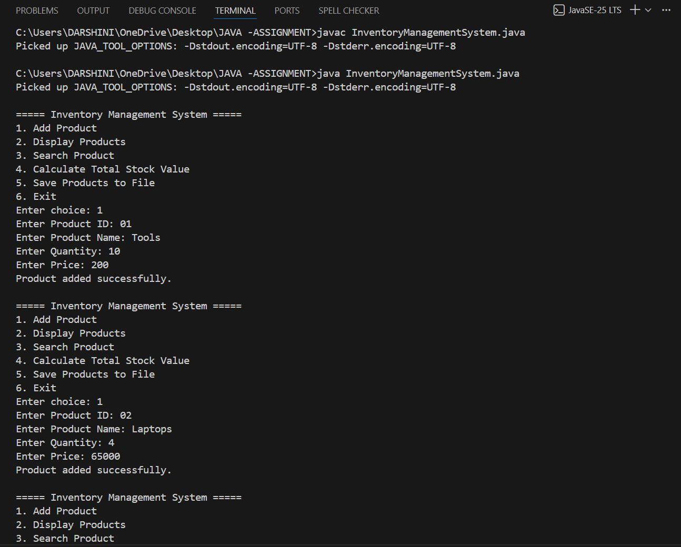
Invalid Product ID entries are detected and are not stored.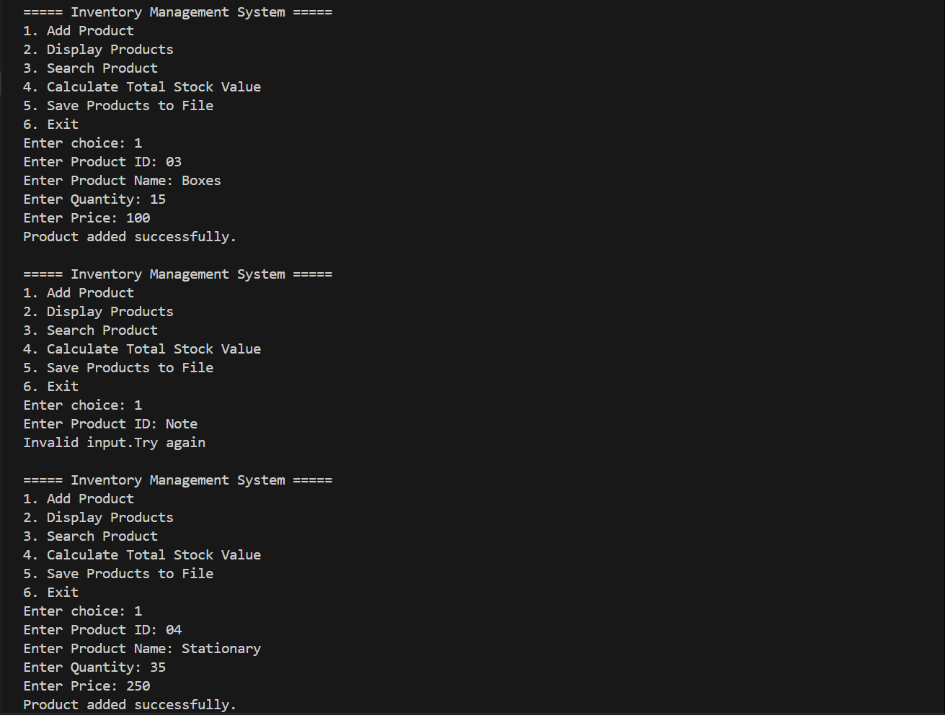
Displaying the 5 entered Products: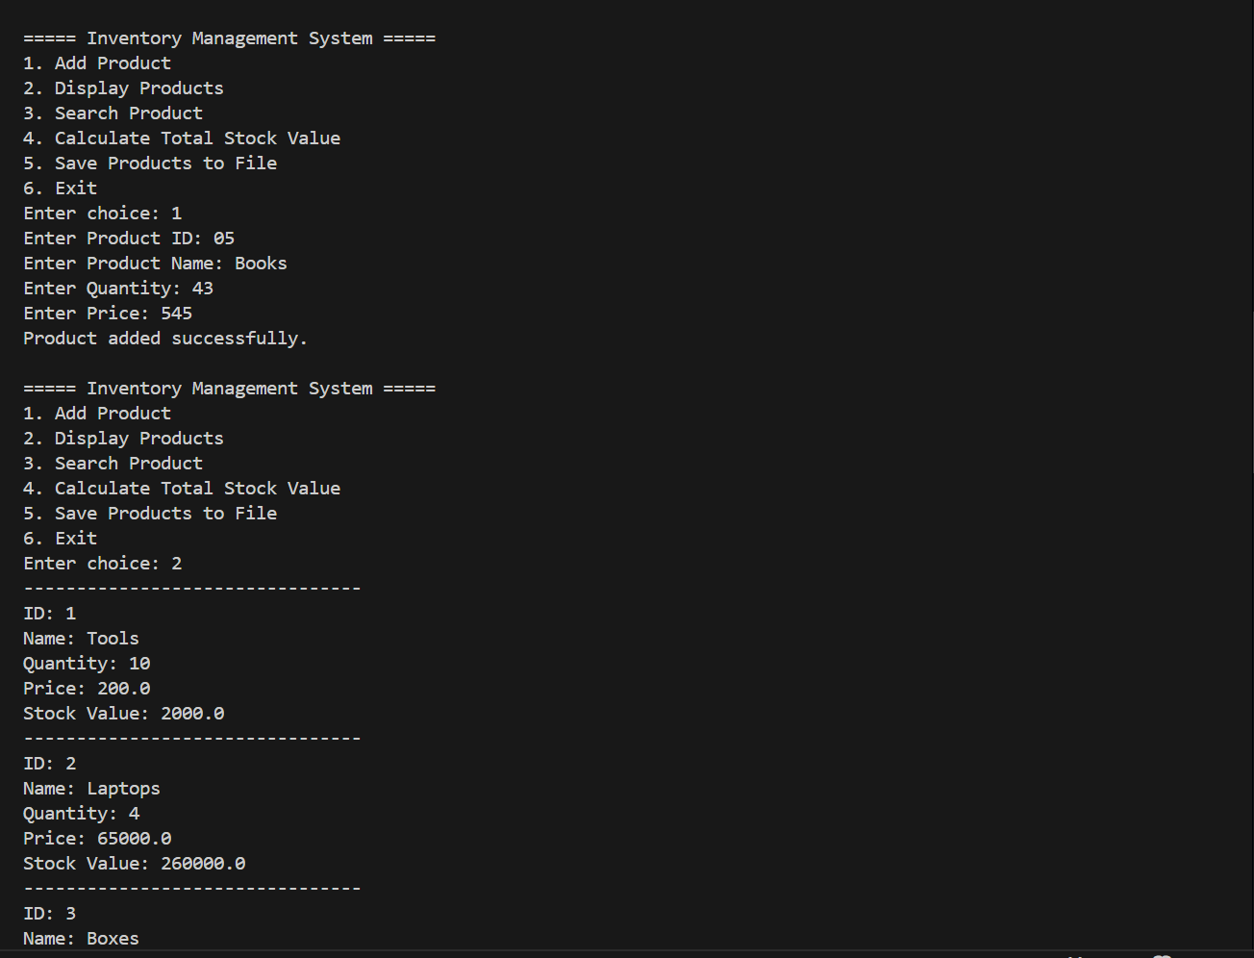

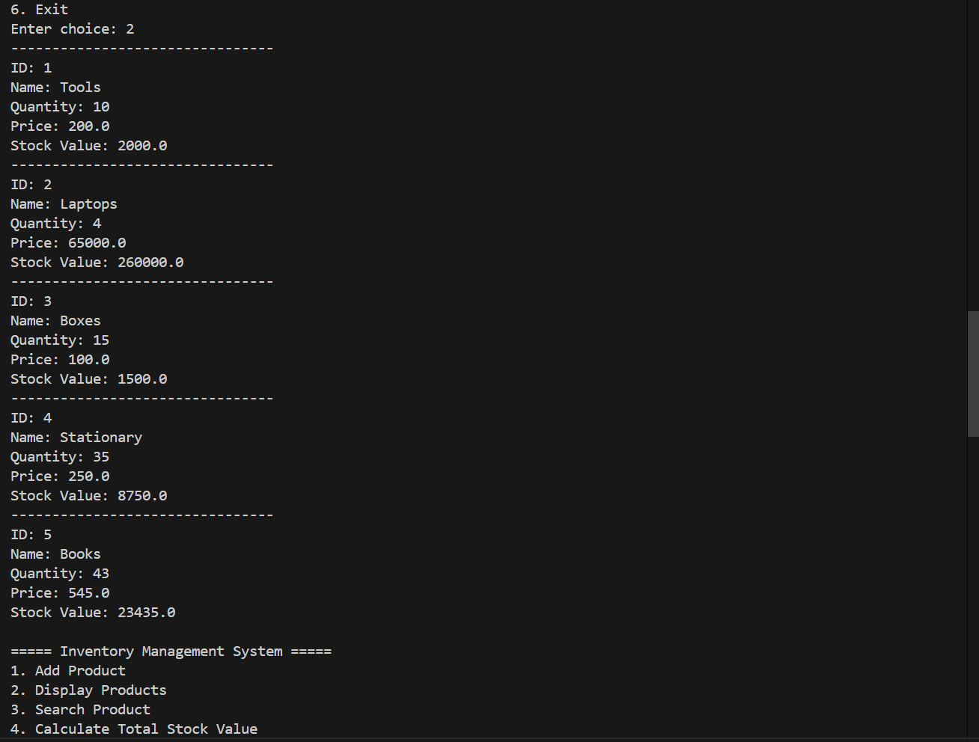

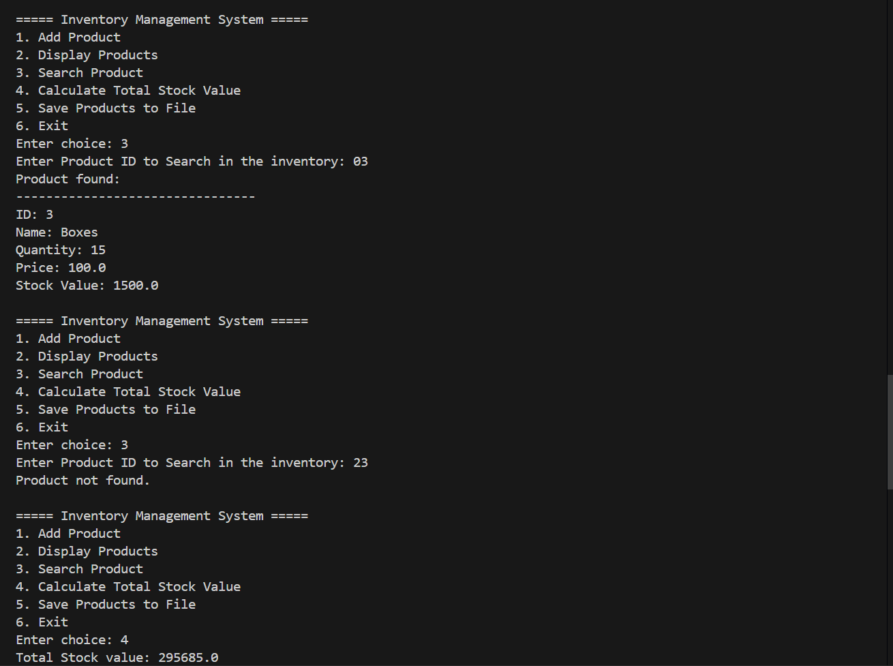
Products are searched by ID and displayed if present. Invalid entries leads to a message displaying that the product is not found.

Total Stock value is Displayed.
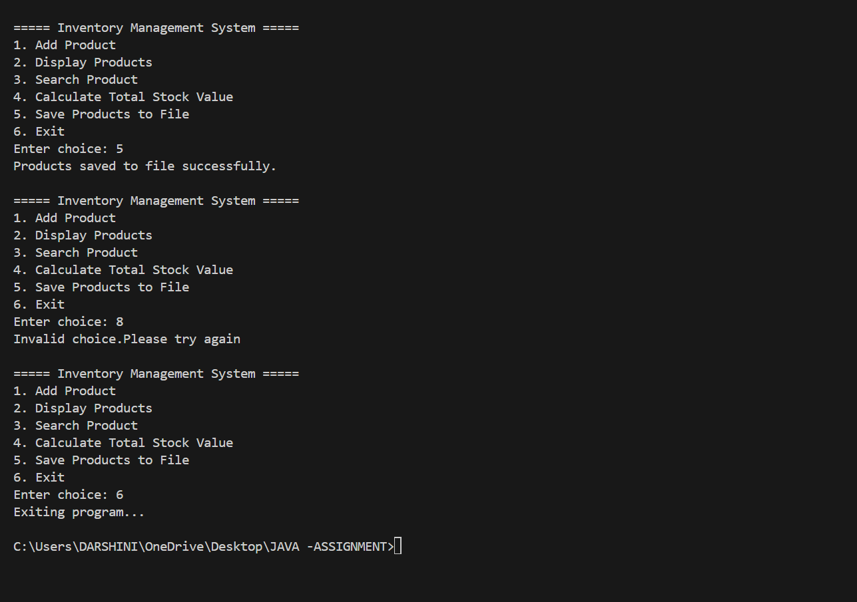
5 Products were added and Saved to the products.txt file.
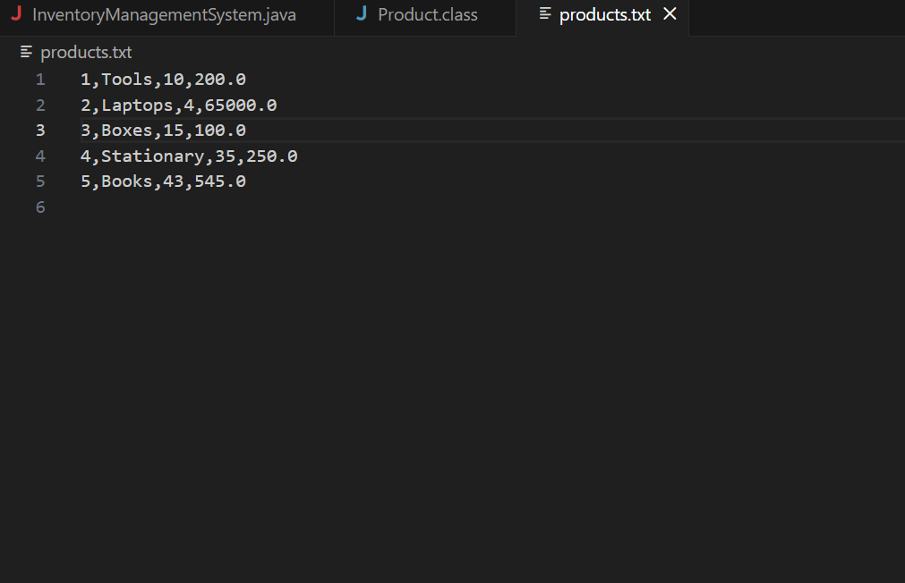
Existing products.txt file

Retrieving existing data from saved file and making changes to it:
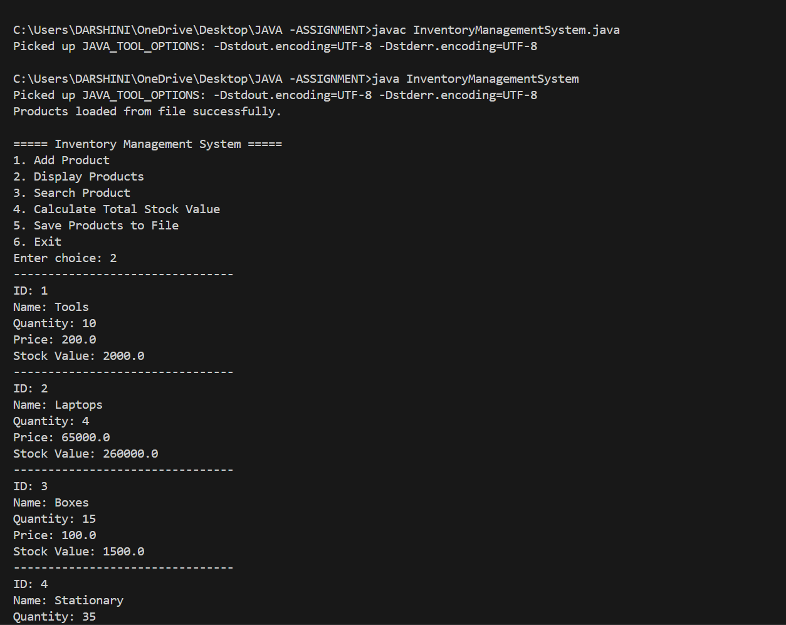
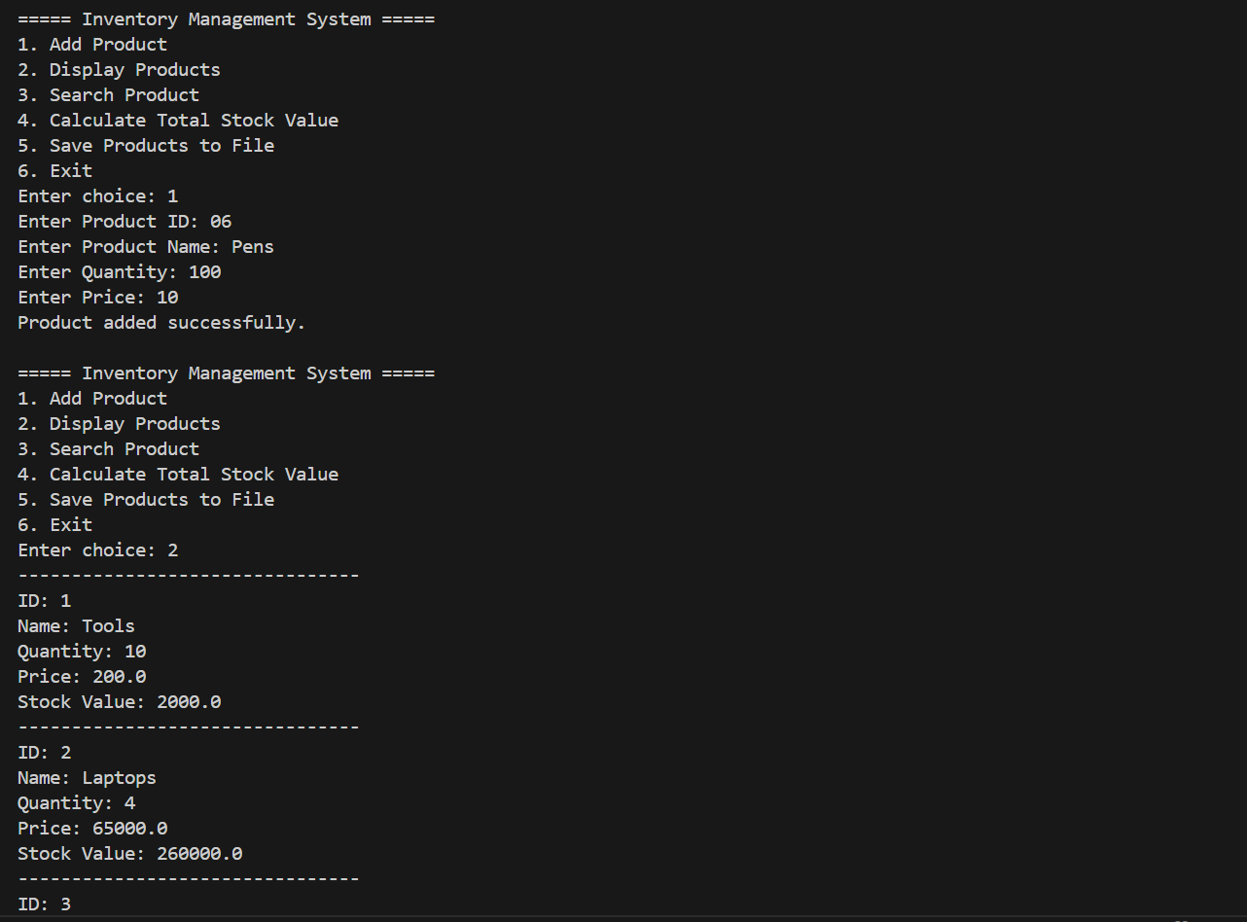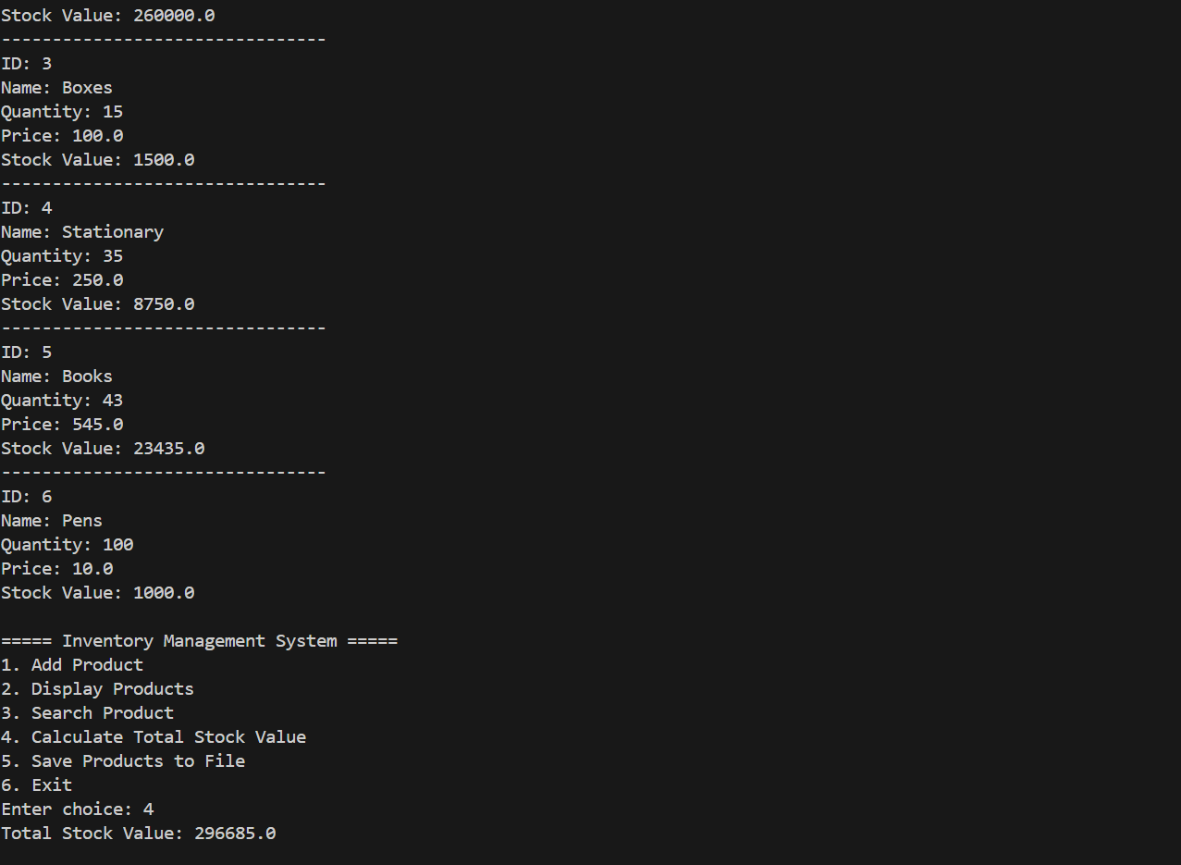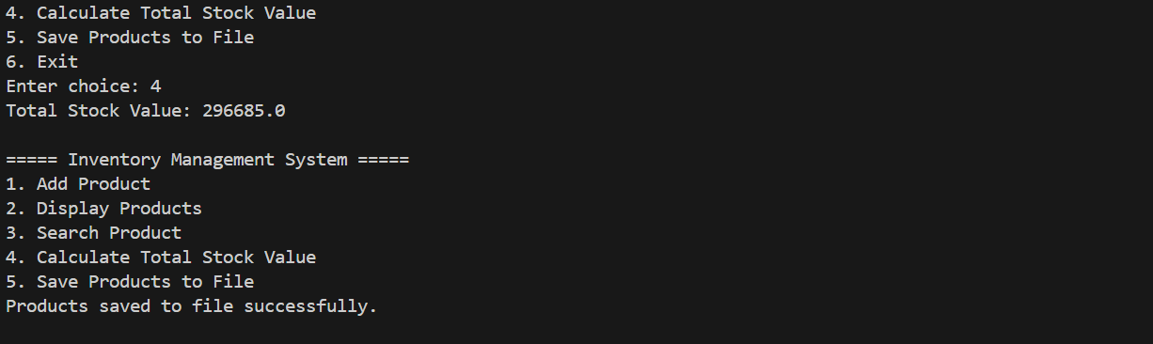

Pens were added to the products.txt file.
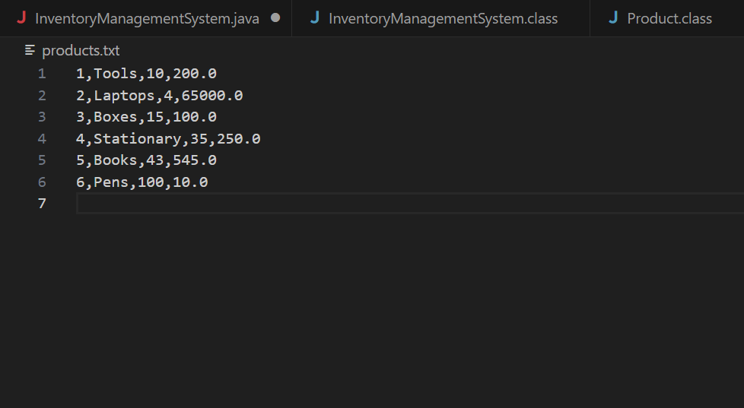
CONCLUSION:
Java programming concepts like OOP, file handling, collections, and exception handling are successfully implemented in the Inventory Management system.
The system offers a straightforward and efficient method for digital inventory record management. It guarantees that product data is stored permanently and makes retrieval simple upon program restart.
This project improves practical knowledge of Java and lays the groundwork for future development of more sophisticated inventory systems. This system can be developed into a comprehensive business solution with additional enhancements like database integration and GUI implementation.

